**Project Report**

**Title:** Augmented Reality-Based Switchboard Functionality Visualization using Vuforia Model Target.

**Submitted By – Anmol Shrivastava**

**E23CSEU0068**

**1. Introduction**

The project aims to create an **AR-based application** that allows users (such as electricians, workers, or students) to scan a physical **switchboard** and visualize its functionalities directly on their mobile device. Using **photogrammetry, 3D modelling, Vuforia Model Target Generator (MTG), and Unity3D**, the project demonstrates how AR can simplify hardware understanding and maintenance.

**2. Objectives**

* To build an AR application capable of recognizing a switchboard in real-time.
* To overlay digital labels, arrows, and text descriptions on the recognized model.
* To provide electricians and technicians with an interactive way to identify switchboard functionalities.
* To explore the workflow of photogrammetry → 3D modelling → AR integration.

**3. Tools & Technologies Used**

* **Polycam** → For 3D scanning (photogrammetry of switchboard).
* **Blender** → For mesh cleaning, refinement, and optimization.
* **Vuforia Model Target Generator (MTG)** → For training the model target (dimensions, guide views, recognition vectors).
* **Unity 2022 LTS** → For integrating Vuforia database, UI overlays, arrows, and interaction logic.
* **C# Scripting** → To ensure that UI elements (arrows & text) always face the AR camera.
* **Android Build System** → To export and test the APK file.

**W O R K F L O W**

**Capture Model - (Polycam Photogrammetry)**

**▼**

**Refine Model - (Blender: clean & optimize)**

▼

**Train Model in MTG - (Dimensions, guide view, vectors)**

▼

**Import to Unity - (Add AR Camera, DB, Model Target)**

▼

**Add UI Overlays & Script - (Arrows, text, face camera)**

▼

**Build & APK - (Android Test)**

**4. Methodology**

**Step 1: 3D Model Creation**

* The switchboard was captured using **Polycam** (photogrammetry).

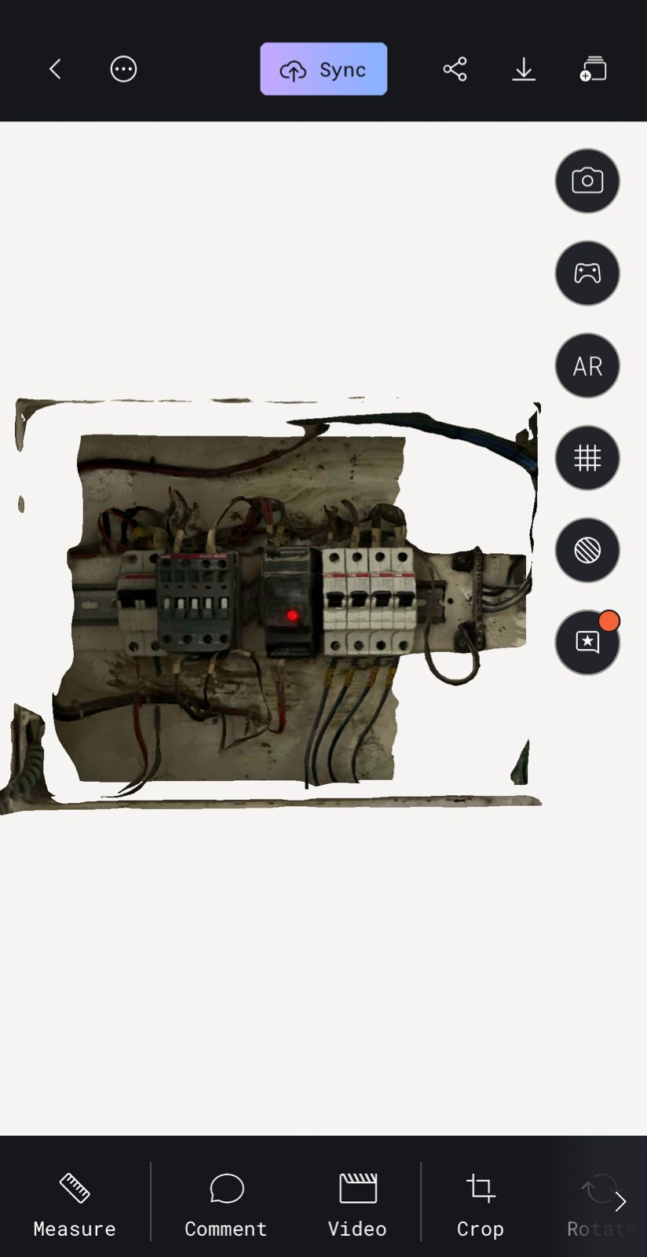

* The raw model was exported and imported into **Blender**.

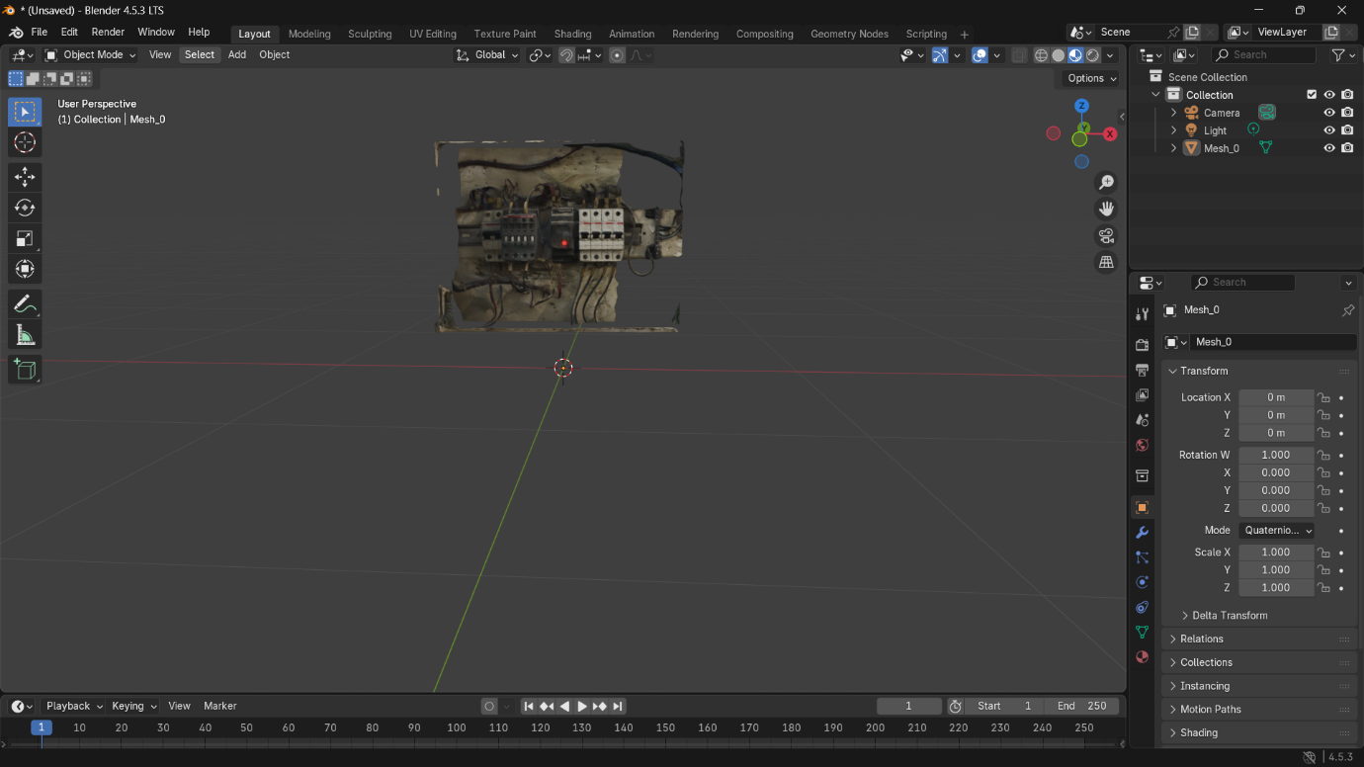

* In Blender: unnecessary noise/mesh was removed, scaling adjustments made, and the model cleaned for AR usage.

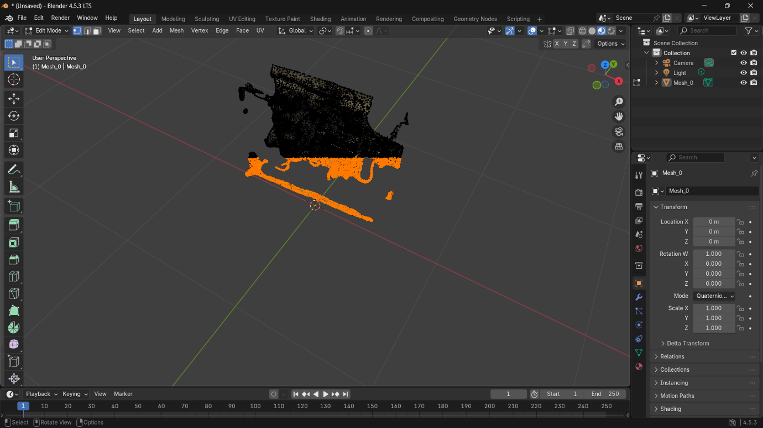

* Finally, the refined model was exported in **FBX format**.

**Step 2: Training in Vuforia MTG**

* The FBX model was imported into **Vuforia Model Target Generator**.

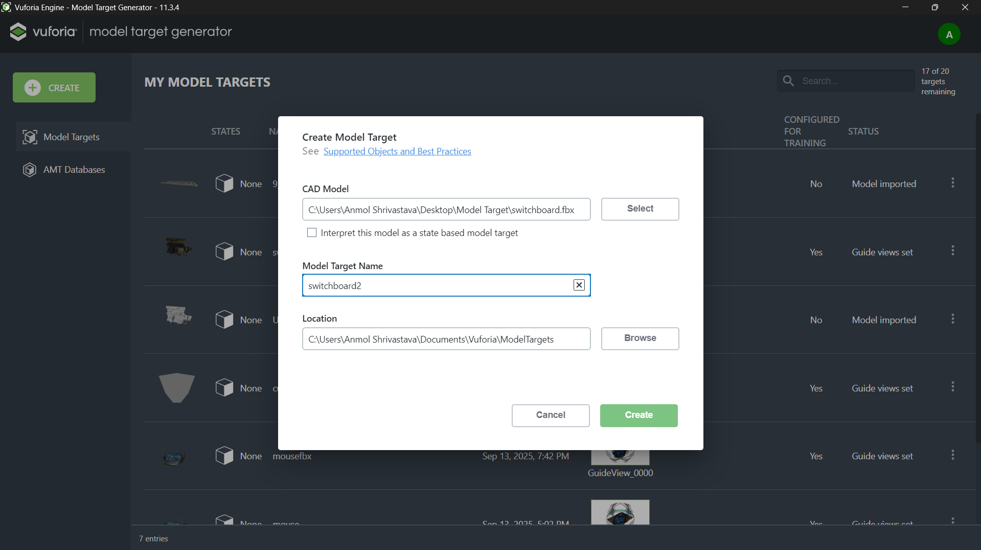

* Model dimensions were set according to real-world measurements.

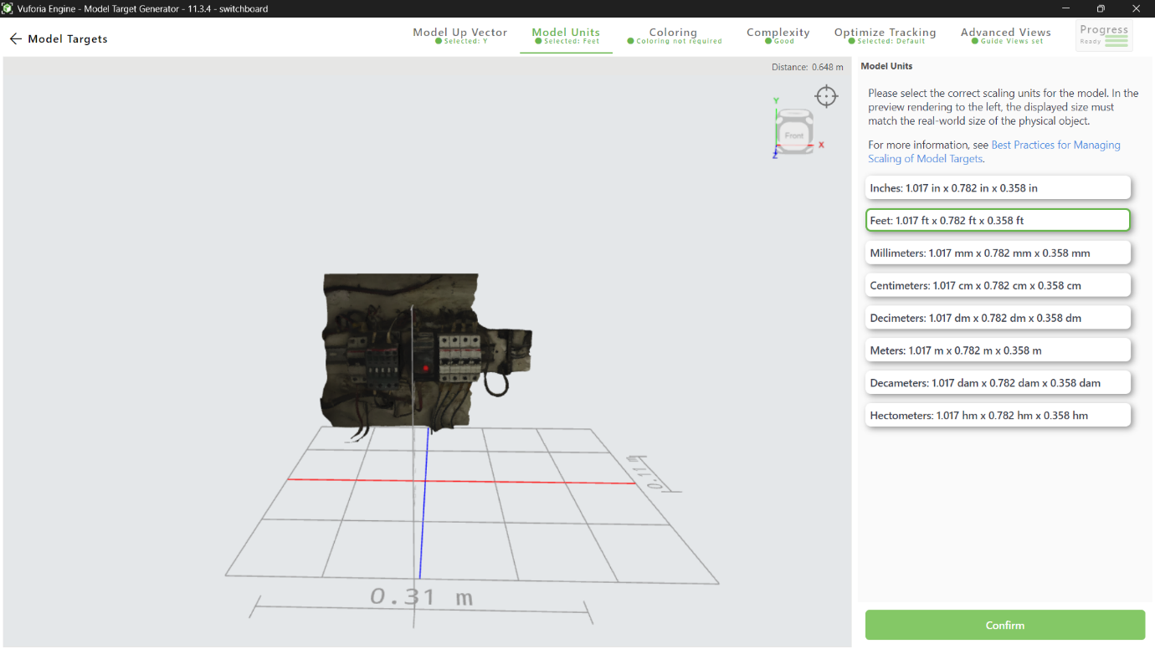

* A **Guide View** was created to define the scanning orientation.

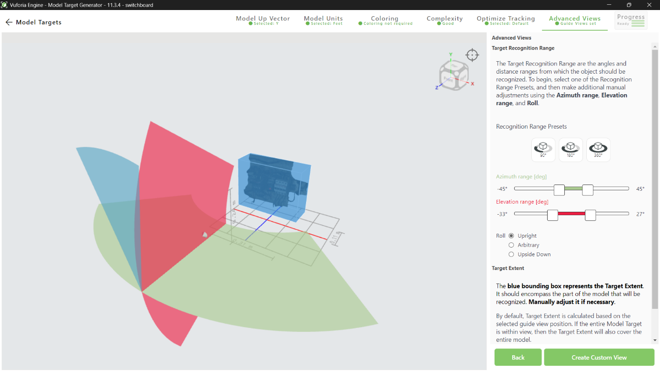

* Appearance and **detection vectors** were configured to optimize recognition.

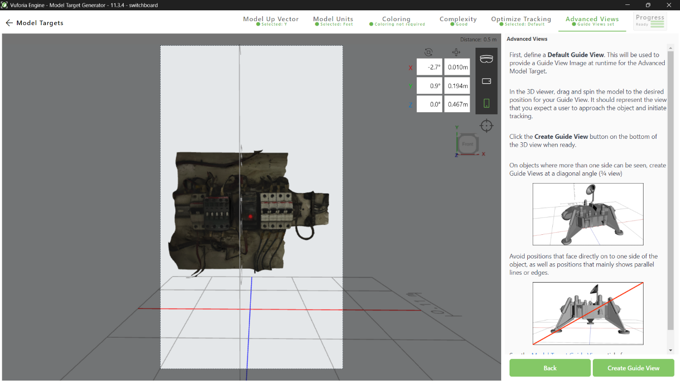

* The model was trained (~2 hours) and exported as a **Vuforia Database** (.unitypackage).

**Step 3: Unity Integration**

* Unity 2022 LTS project created.
* Imported the **Vuforia Database**.

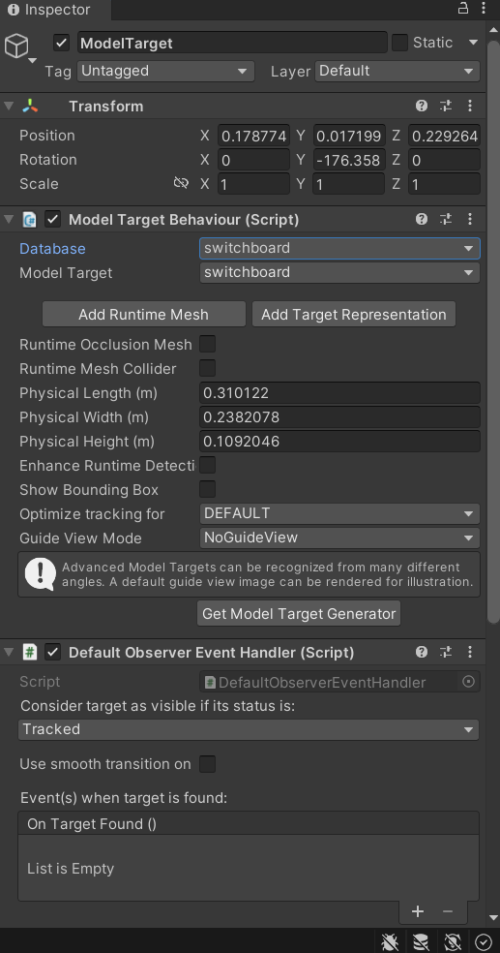

* Set up **AR Camera** with Vuforia Engine.

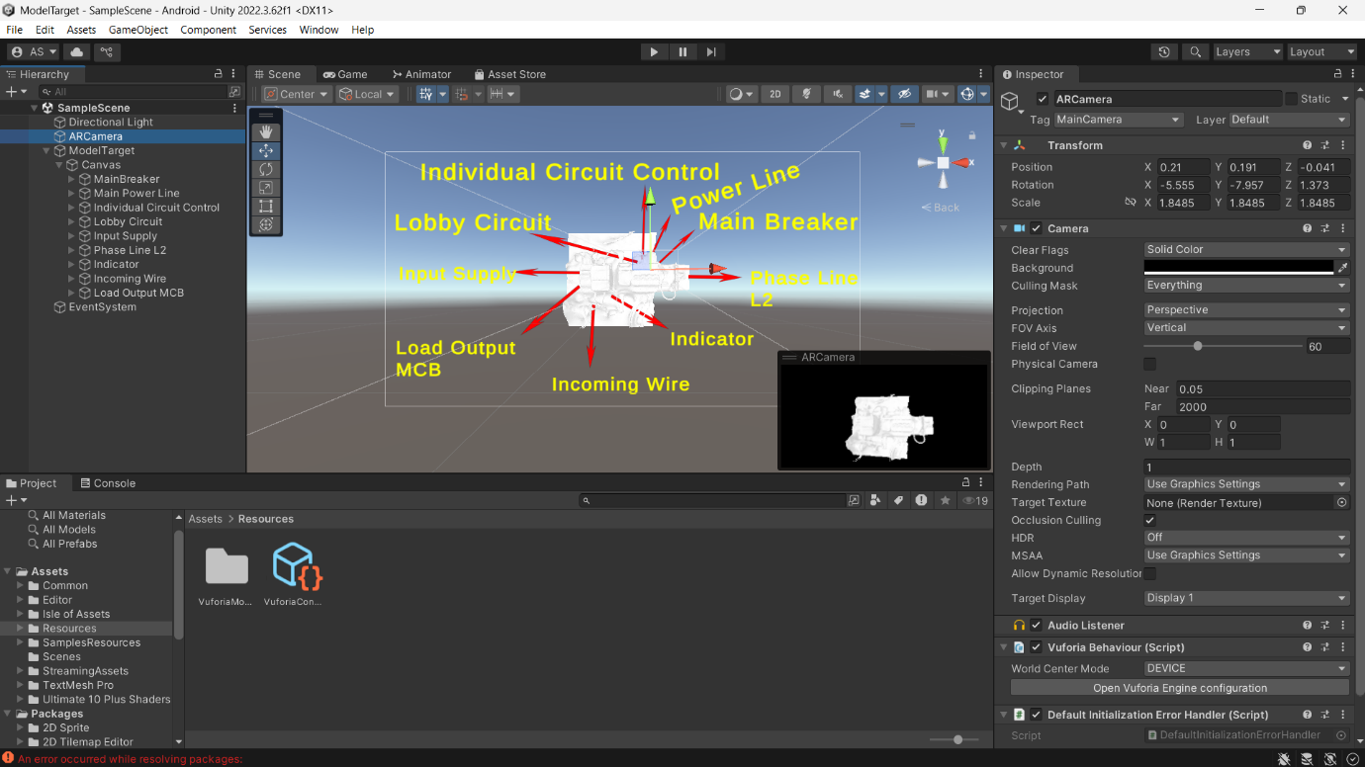

* Added the **Model Target GameObject** from the database.
* Adjusted alignment so that digital overlays matched the real-world switchboard.

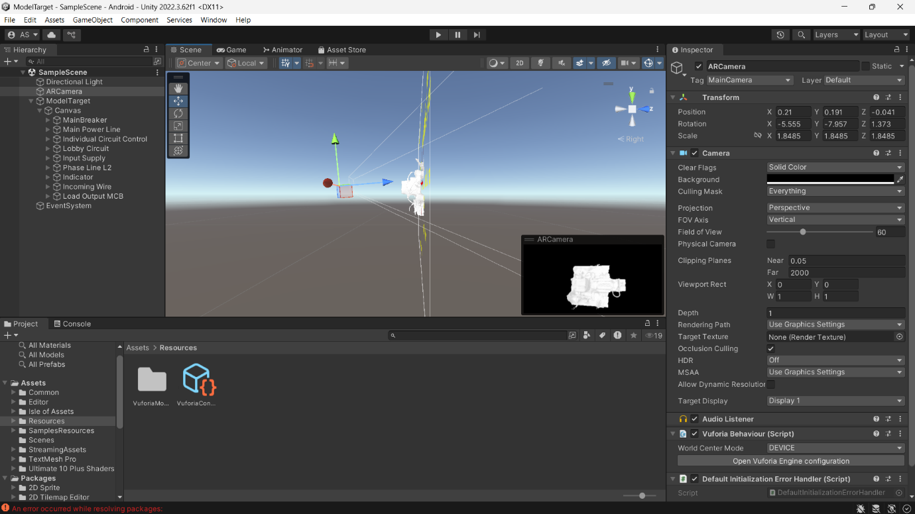

**Step 4: Adding UI Overlays & Functionality**

* Created a **Canvas** with UI elements (arrows, text labels).
* Attached labels to specific switches/components (e.g., “Main Switch,” “Fan Switch,” “Light Switch”).

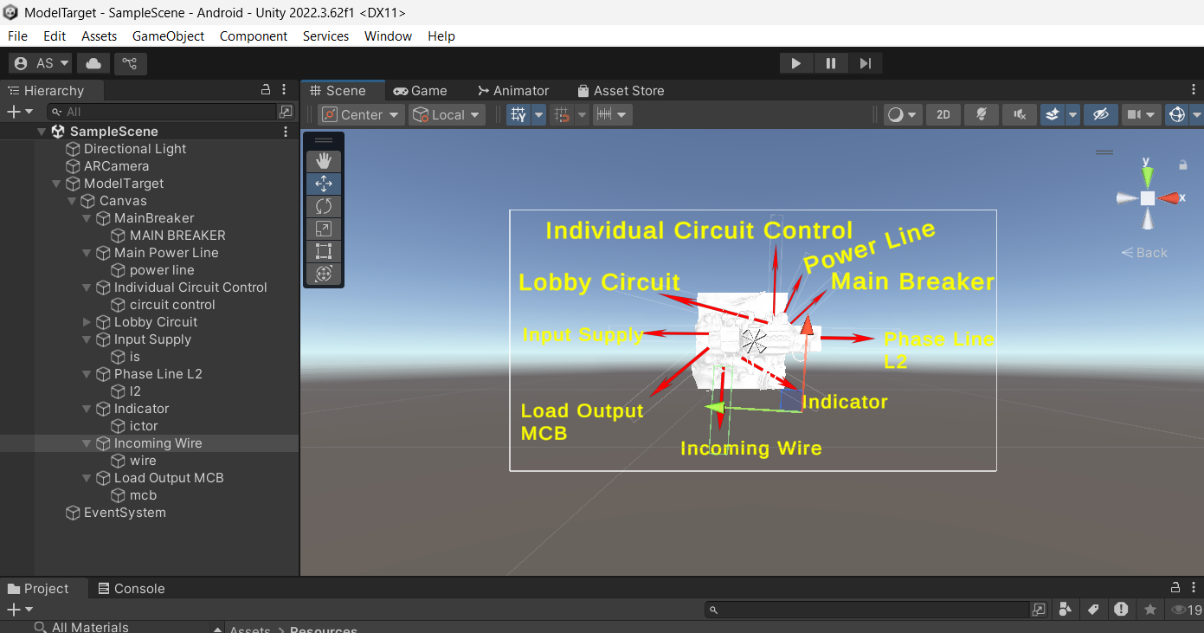

* Implemented a **C# script** so that all UI elements **always face the AR Camera**.

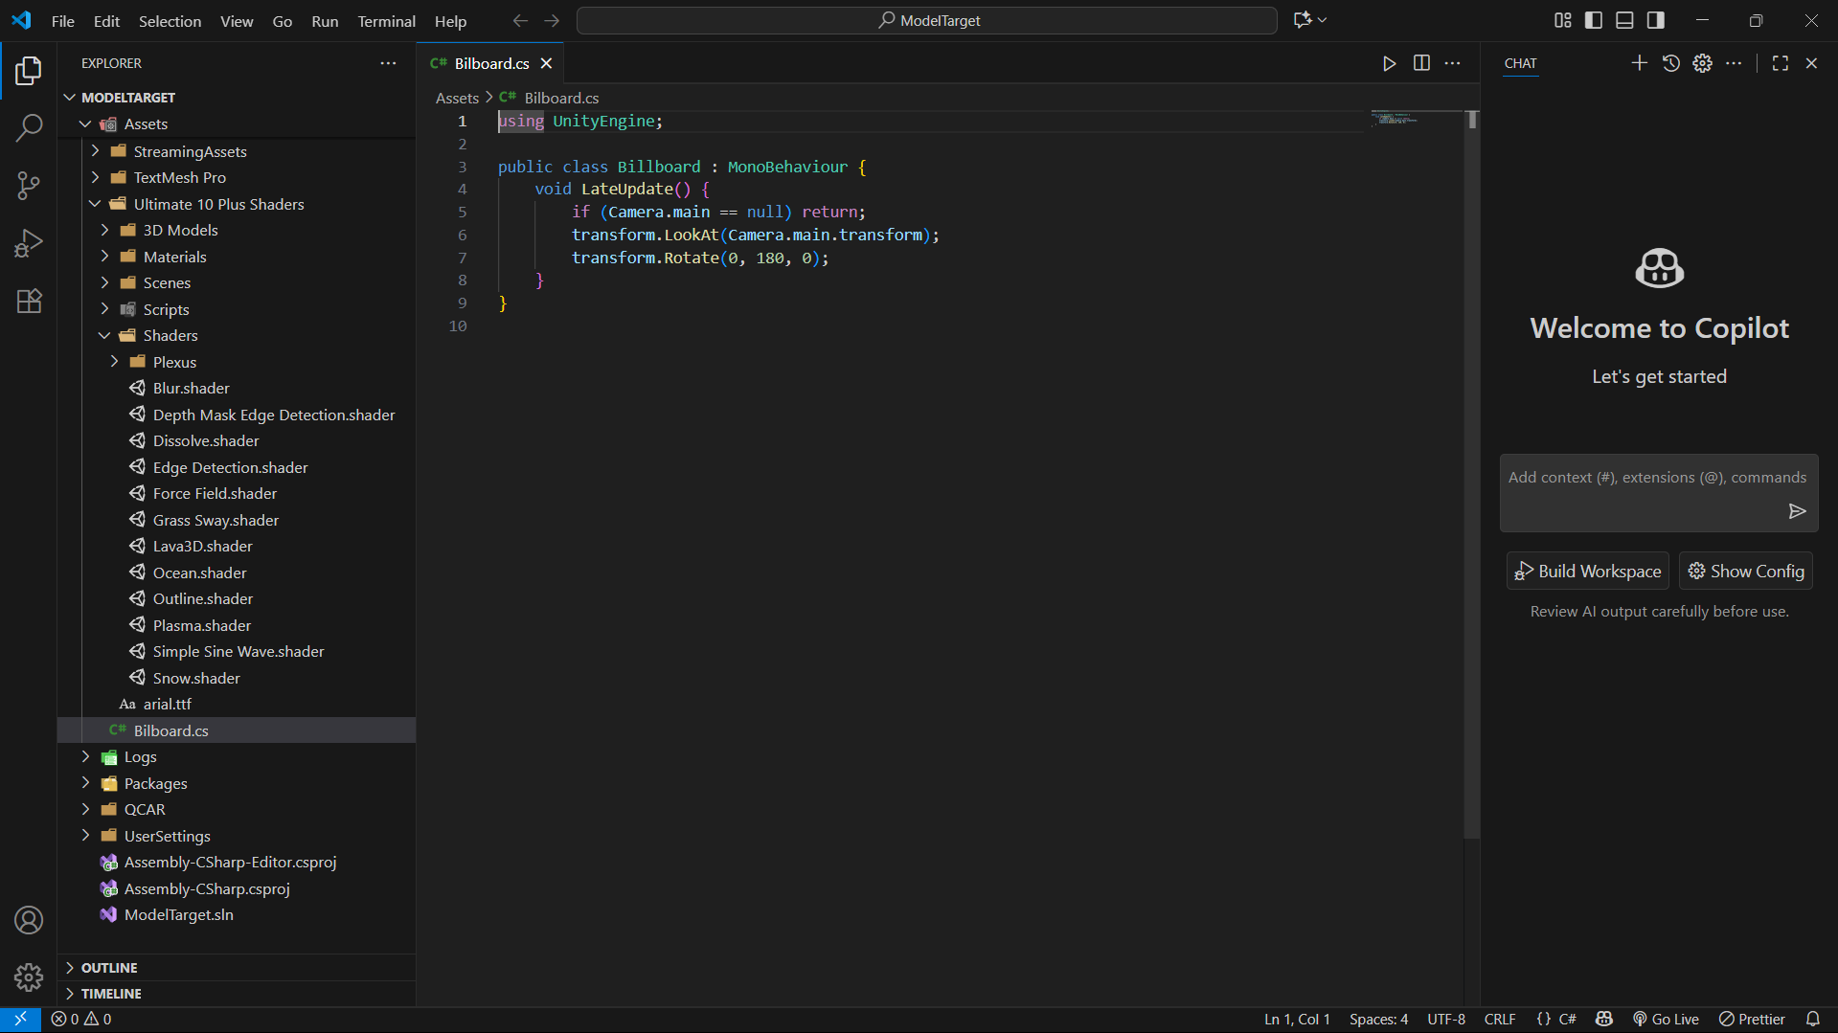

**Step 5: APK Build & Testing**

* Built the AR application for Android.

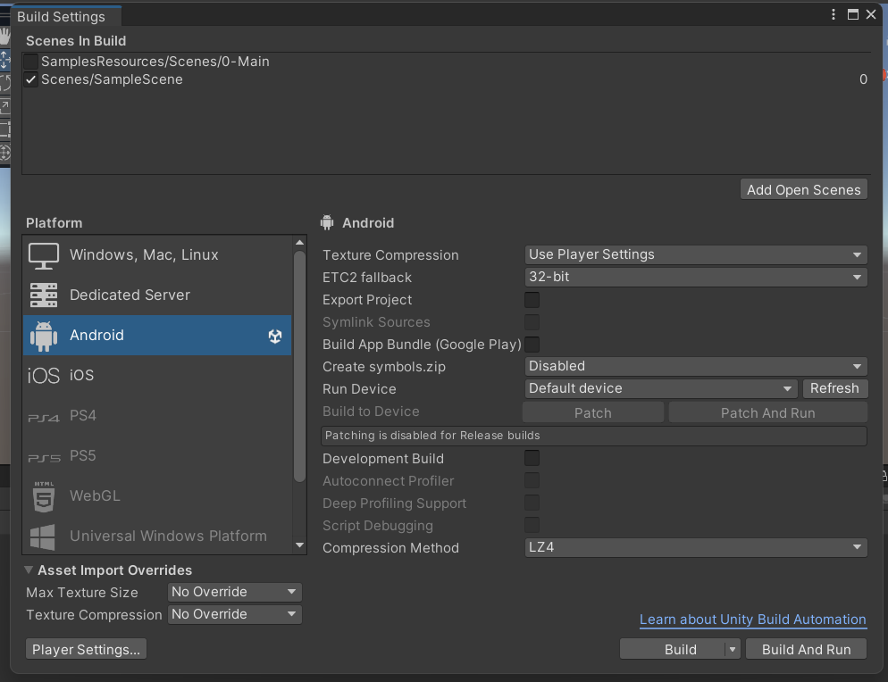

* Installed APK on mobile device.
* Tested by scanning the physical switchboard:
  + The AR app recognized the switchboard.
  + Functional labels appeared correctly aligned.
  + Arrows & text dynamically faced the camera for readability.

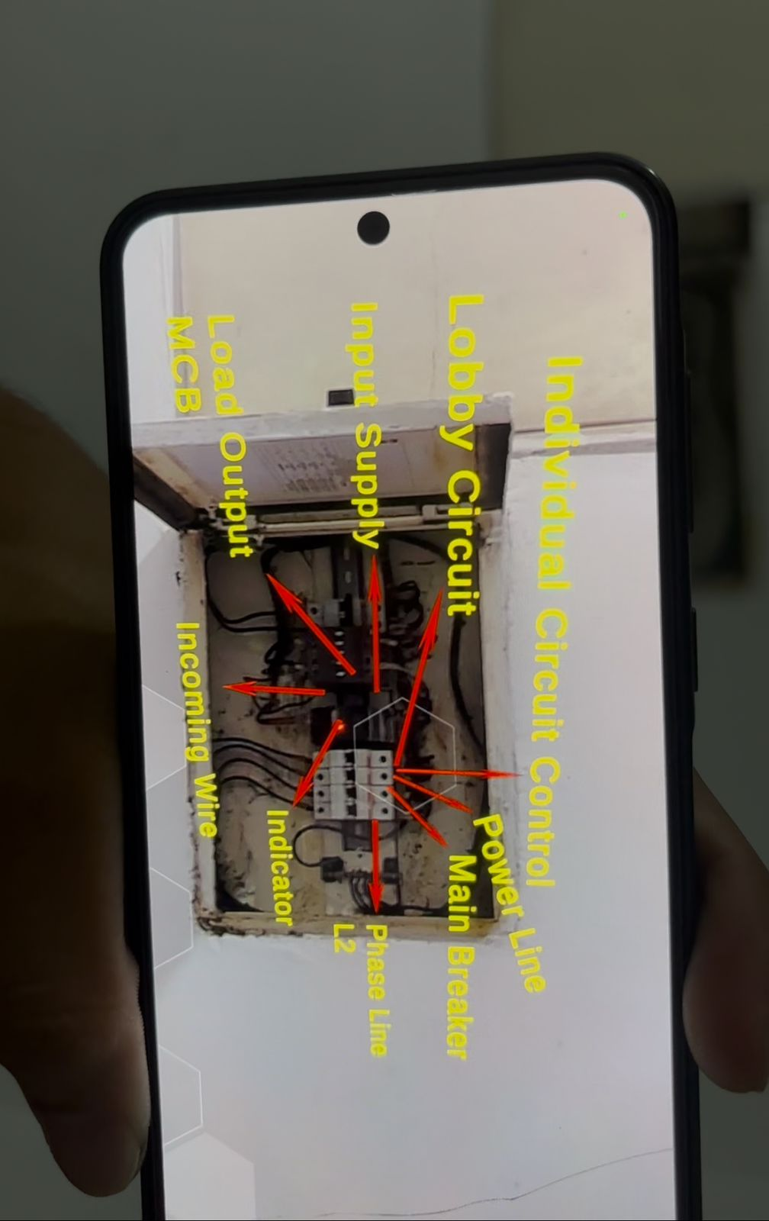

**5. Results**

* Successfully created an AR app that recognizes a real-world switchboard.
* Functionalities of each switch are highlighted with AR overlays.
* Application is **portable (APK)** and can be installed on any Android device.

**6. Applications**

* **Industrial Training:** Quick training for electricians & technicians.
* **Education:** Teaching students about circuits & switchboards.
* **Maintenance:** Assisting in identifying circuit elements during troubleshooting.

**7. Conclusion**

* This project demonstrates the integration of photogrammetry, 3D modelling, and AR recognition to enhance real-world hardware understanding. By overlaying functional information directly on the physical object, AR helps bridge the gap between theory and practical hardware usage.